# Rio Demo

The article is intended to give an introduction to Rio by way of example. Certain features of Rio will be demonstrated. This article is written in a way that it can double as a turoral. You are invited to follow alonge.

## Rio Concepts

Rio is a MicroPaaS that can be layered on top of any standard Kubernetes cluster. To understand Rio we will need to understand a few basic Rio concepts:

* **Service** – Scalable set of containers that provide a similar function.
* **App** – Contains multiple service revisions. Each revision gets it’s own DNS name.
* **Router** – Virtual service that routes and load balances traffic. Rules based on hostname, path, headers, protocol & source.
* **External Service** – A way of registering external IPs or hostnames into the service mesh such that they may be accessed via short name.
* **Service Mesh** – Istio service mesh, deployed for securing, routing, monitoring, and controlling inter- and intra- service traffic.

## Service Mesh

A *service mesh* is a large topic one that we can not adequately cover here, see the [Istio Docs](https://istio.io/docs/concepts/what-is-istio/) for more information. However, it is worth pointing out a few key featrue so that we can understand better what is happening.

Istio will install a proxy on each pod, a “sidecar”. The proxy implements L7 routing which enables Isto to implment certain features such as:

* circuit breakers
* policy enforcement
* metrics collection and reporting
* security
  + defend against *man-in-the-middle* attack
  + service access control
  + audit who did what at what time

All traffic entering and leaving the pod is routed via the proxy without requiring any application changes

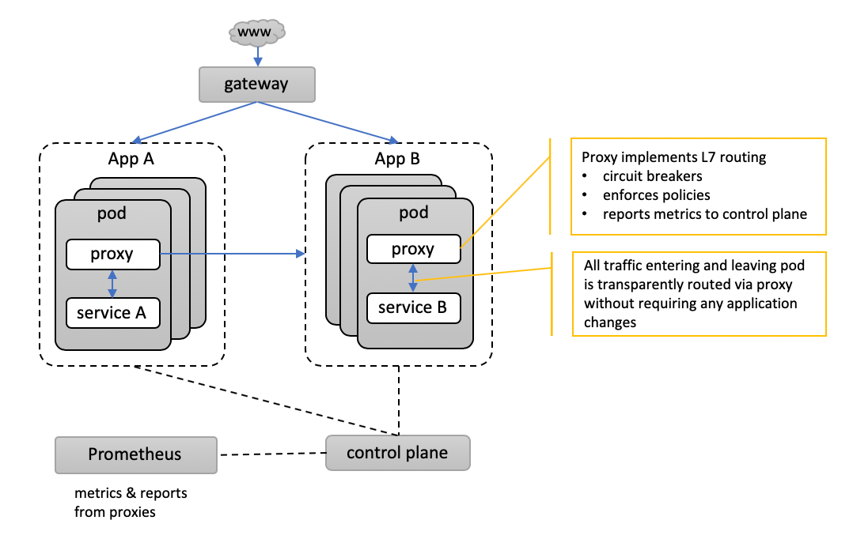

service mesh

## Prerequisites

To run the demo you will need the following:

* A Kubernetes 1.13 or newer cluster running. I am using [Docker Desktop](https://docs.docker.com/docker-for-mac/install/) to host a cluster on my Mac
* The kubectl CLI installed and pointed at your cluster. See the [Kubernetes official doc](https://kubernetes.io/docs/tasks/tools/install-kubectl/) for install and setup instructions
* The hey program used for load testing. See [the hey GitHub page](https://github.com/rakyll/hey) for install instructions
* The *Rio CLI*. The install instruction can be found on [the Rio GitHub page](https://github.com/rancher/rio)

# Download the CLI (available for macOS, Windows, Linux)  
curl -sfL https://get.rio.io | sh -   
  
# Install Rio into the cluster  
# Using service loadbalancer (mode=svclib) because my cluster does have an ingress  
$ rio install --mode svclib  
  
Deploying Rio control plane....  
rio controller version v0.4.0 (a8d35ef9) installed into namespace rio-system  
Detecting if clusterDomain is accessible...  
ClusterDomain is reachable. Run `rio info` to get more info.  
Controller logs are available from `rio systemlogs`  
  
Welcome to Rio!  
  
Run `rio run https://github.com/rancher/rio-demo` as an example  
   
  
# Check the status  
$ rio info  
Rio Version: v0.4.0 (a8d35ef9)  
Rio CLI Version: v0.4.0 (a8d35ef9)  
Cluster Domain: xvw8xv.on-rio.io  
Cluster Domain IPs: 127.0.0.1  
System Namespace: rio-system  
  
System Components:  
Autoscaler status: running  
BuildController status: running  
CertManager status: running  
Grafana status: running  
IstioCitadel status: running  
IstioPilot status: running  
IstioTelemetry status: running  
Kiali status: running  
Prometheus status: running  
Registry status: running  
Webhook status: running  
  
# The rio console is a text basse UI (TUI)  
rio console

## Demo Containers

To get started we need a few docker containers to use in our demo. For this purpose we will build a few images and store them in our local container registry. Start by cloning this repo. All command in this article assume you are in the project root folder.

Build the docker images:

$ git clone https://github.com/MileTwo/riodemo.git  
$ cd riodemo  
$ docker build --build-arg COLOR=yellow -t flower:yellow .  
$ docker build --build-arg COLOR=blue -t flower:blue .  
$ docker build --build-arg COLOR=red -t flower:red .

The above commands will build a few docker images that are used throught this demo. The same simple [golang program](https://github.com/MileTwo/riodemo/blob/master/src/main.go) is use in each image. The program will responds to any http request with the color sepcified in the environment varable.

Let’s test our images before we jump into Rio, just to be sure all is good. Use docker run to create a container and in a second terminal (or in your browser) issue an HTTP GET to your service.

$ docker run -it --rm -p 8080:80 flower:yellow  
$ curl http://localhost:8080  
{"Color":"yellow"}  
^C  
  
$ docker run -it --rm -p 8080:80 flower:blue  
$ curl http://localhost:8080  
{"Color":"blue"}  
^C  
  
$ docker run -it --rm -p 8080:80 flower:red  
$ curl http://localhost:8080  
{"Color":"red"}  
^C

## Demo Display Setup

In order to follow the script below you may want to arange several terminal windows and a browser window so that all are visable on your desktop.

* Desktop 1
  + *Terminal-1* - Use to run watch rio ps. This command will display the service endpoints and information about the current revision, scale and weight.
  + *Terminal-2* - Use to run watch rio ps --containers. This command will display our service containers and the docker image they are based on.
  + *Terminal-3* - Command terminal use to issue commans throughout our demo
* Desktop 2
  + *Browser* - Used to view this README, the Kailai and Grafana UIs throughout the demo. To get the URLs for Kailai and Grafana run rio -s ps. The default user name is *admin* and the default password is *admin*

Your setups should look something like this:

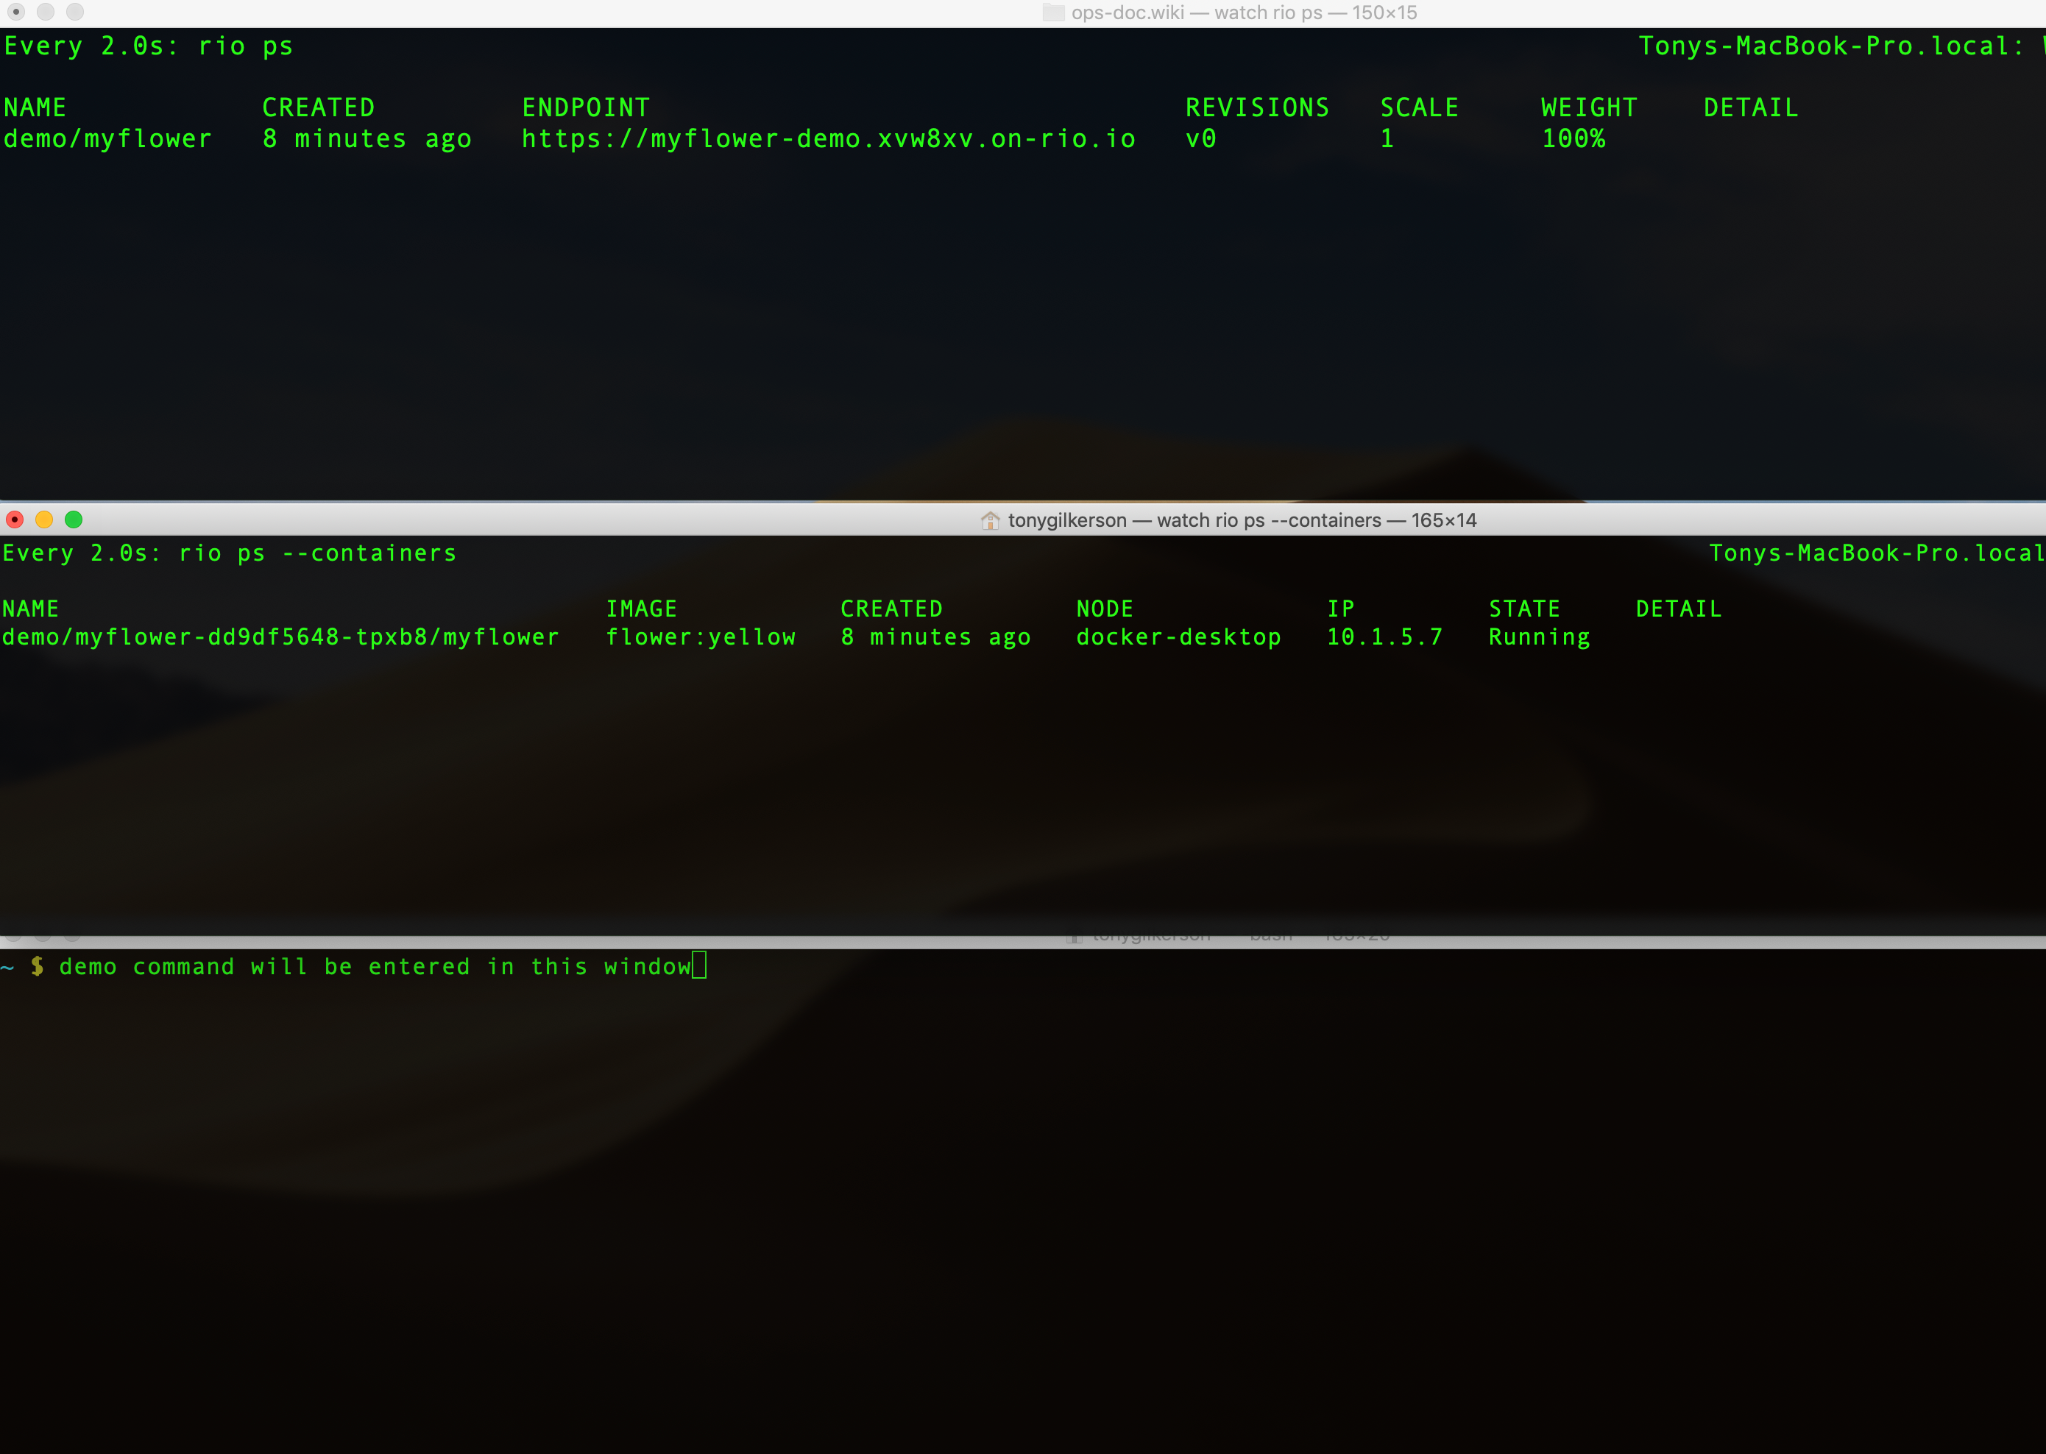

demo setup

## Create a Rio Service

To create a Rio service in your kubernetes cluster use the rio run command as shown below. Before continuning be sure you stop all the containers from above.

# create a new service  
$ rio run --ports 80/http --name demo/myflower flower:yellow  
demo/myflower:v0

This rio run command created a service called myflower in the demo namespace. The service is an instance of the flower:yellow docker image. The following is sample output from rio ps running in *Terminal-1*

Name CREATED ENDPOINT REVISIONS SCALE WEIGHT DETAIL  
demo/myflower 27 seconds ago https://myflower-demo.xvw8xv.on-rio.io v0 1 100%

Using the endpoint URL displayed above let’s test our service.

$ curl https://myflower-demo.xvw8xv.on-rio.io  
{"Color":"yellow"}

Let’s try pasting the endpoint URL into out browser. Notice that the TLS cert is valid.

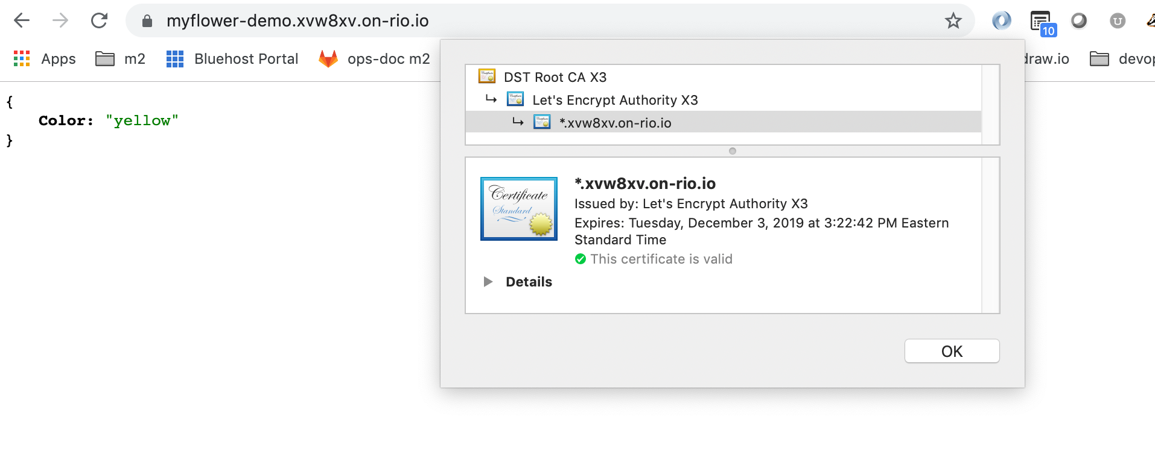

browser cert

Let’s see what it looks like in Kiali

rio -s ps  
  
#looks for  
https://kiali-rio-system.3lzq3l.on-rio.io

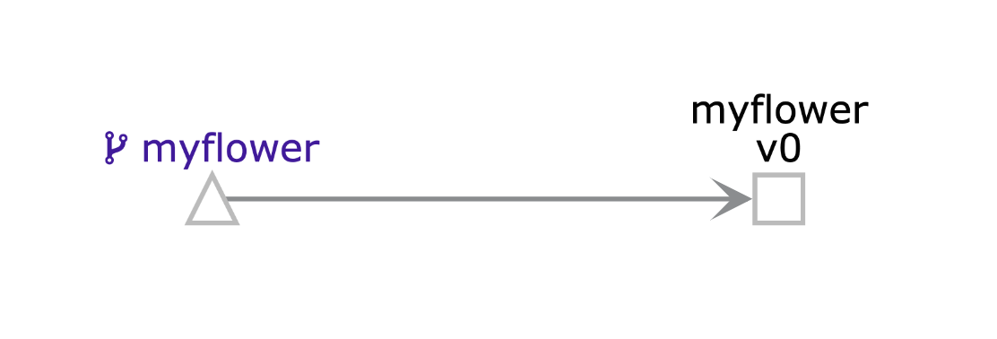

kiali initial

## Auto scale a service

Let’s explore the auto scale features of Rio using the service we just created. Rio will default the service scale to min=1 and max=10 containers. Use the rio inspect to view the scaling properties.

$ rio inspect demo/myflower  
  
...  
spec:  
 concurrency: 10  
 image: flower:yellow  
 imagePullPolicy: IfNotPresent  
 maxScale: 10  
 minScale: 1  
...

We will use hey to put load on our service, however it does not support TLS so the unsecure URL http://myflower-demo.xvw8xv.on-rio.io is used instead.

# Add load, make 60 requests concurrently for 1 minutes  
$ hey -z 1m -c 60 http://myflower-demo.xvw8xv.on-rio.io

Watch the output in *Terminal-1* where we are displaying rio ps and take note of the SCALE column.

# timestamp 1 - start load  
Name CREATED ENDPOINT REVISIONS SCALE WEIGHT DETAIL  
demo/myflower 22 minutes ago https://myflower-demo.xvw8xv.on-rio.io v0 1 100%  
  
# timestamp 2 - SCALEs up under load  
Name CREATED ENDPOINT REVISIONS SCALE WEIGHT DETAIL  
demo/myflower 23 minutes ago https://myflower-demo.xvw8xv.on-rio.io v0 3 100%  
  
# timestamp 3 - SCALEs up some more under load  
Name CREATED ENDPOINT REVISIONS SCALE WEIGHT DETAIL  
demo/myflower 23 minutes ago https://myflower-demo.xvw8xv.on-rio.io v0 7 100%  
  
# timestamp 4 - no more load for awhile, SCALE down starting  
Name CREATED ENDPOINT REVISIONS SCALE WEIGHT DETAIL  
demo/myflower 25 minutes ago https://myflower-demo.xvw8xv.on-rio.io v0 4 100%  
  
# timestamp 5 - eventually we SCALE down to 1  
Name CREATED ENDPOINT REVISIONS SCALE WEIGHT DETAIL  
demo/myflower 26 minutes ago https://myflower-demo.xvw8xv.on-rio.io v0 1 100%

Here is what it looked like in *Terminal-2* where we are displaying rio ps --containers Notice that the number of containers correspondes to the SCALE above:

# timestamp 1 - start load  
NAME IMAGE CREATED NODE IP STATE DETAIL  
demo/myflower-dd9df5648-tpxb8/myflower flower:yellow 25 minutes ago docker-desktop 10.1.5.7 Running  
  
# timestamp 3 - SCALEs up some more under load  
NAME IMAGE CREATED NODE IP STATE DETAIL  
demo/myflower-dd9df5648-b5wz7/myflower flower:yellow About a minute ago docker-desktop 10.1.5.12 Running  
demo/myflower-dd9df5648-j9zlx/myflower flower:yellow About a minute ago docker-desktop 10.1.5.9 Running  
demo/myflower-dd9df5648-lmm4m/myflower flower:yellow About a minute ago docker-desktop 10.1.5.10 Running  
demo/myflower-dd9df5648-mmbp9/myflower flower:yellow About a minute ago docker-desktop 10.1.5.8 Running  
demo/myflower-dd9df5648-mwkc9/myflower flower:yellow 21 seconds ago docker-desktop 10.1.5.13 Running  
demo/myflower-dd9df5648-rmbnf/myflower flower:yellow About a minute ago docker-desktop 10.1.5.11 Running  
demo/myflower-dd9df5648-tpxb8/myflower flower:yellow 25 minutes ago docker-desktop 10.1.5.7 Running  
  
# timestamp 5 - eventually we SCALE down to 1  
NAME IMAGE CREATED NODE IP STATE DETAIL  
demo/myflower-dd9df5648-tpxb8/myflower flower:yellow 27 minutes ago docker-desktop 10.1.5.7 Running

Here is how the service *graph* looks in Kiali. Use rio -s ps to display the Kiali URL, in my case https://kiali-rio-system.xvw8xv.on-rio.io

Kiali setings:

* Graph Type
  + App
* Namespace
  + demo
* Edge Labels
  + Requests percent of total
* Display
  + Traffic Animation
* Fetching
  + last min
  + every 5 sec

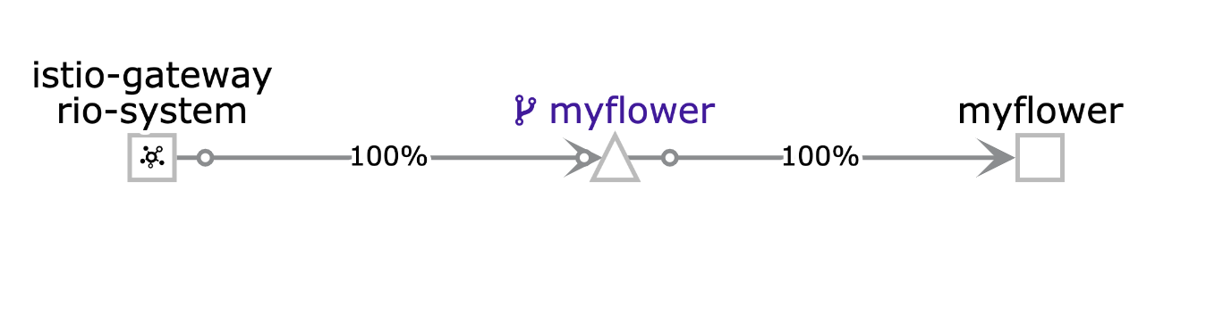

kiali1

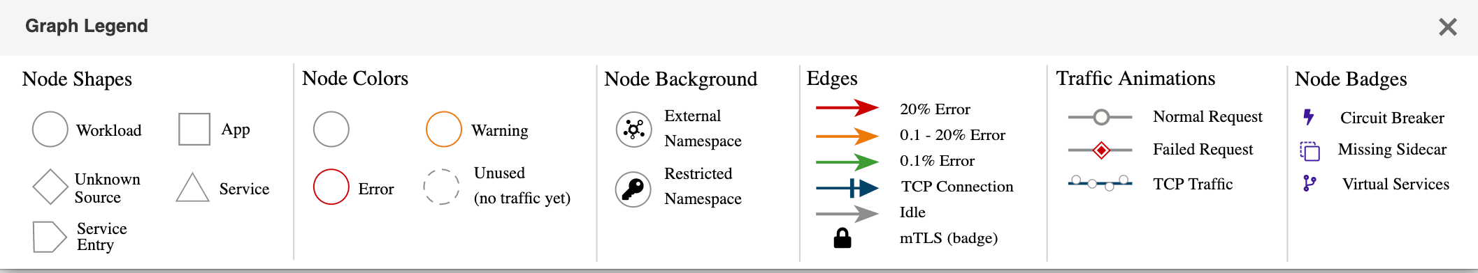

kiali1

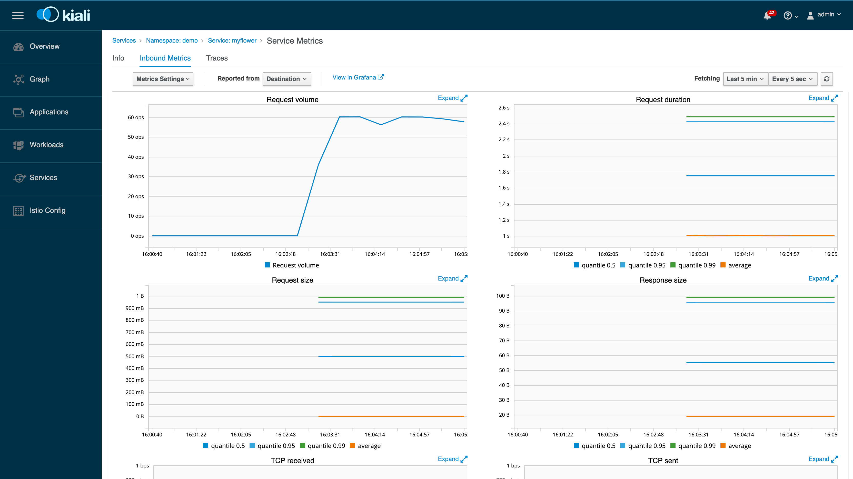

kiali1

## Canary Deployment

In Rio, an **applicaton** contains multiple service revisions. The rio stage command is used to associate a new service revision to an existing application. Therefore the command shown below will:

* create a new service revision based on the flower:blue image
* associate the revision with the myflower application with an initial weight of 0%, meaning it receives 0% of the application’s traffic
* however it will create a new URL for the revision that is functional. This allows for testing before the new revision goes live.

# Stage a new version  
$ rio stage --image=flower:blue demo/myflower

To review an application’s revision use the rio revision command.

$ rio revision demo/myflower  
Name IMAGE CREATED SCALE ENDPOINT WEIGHT DETAIL  
demo/myflower:v40157 flower:blue 24 minutes ago 1 https://myflower-v40157 -demo.xvw8xv.on-rio.io 0   
demo/myflower:v0 flower:yellow About an hour ago 1 https://myflower-v0-demo.xvw8xv.on-rio.io 100

Our initial revision myflower:v0 is based on the flower:yellow image and will receive all of the appliction’s traffic. The revision myflower:v40157 is the one we just staged. I am not sure how the version numbers are determined, I woud have expected v1. At any rate we see this revision has a unique URL and the myflower application too has its own URL. Let’s see what we get when we hit each endpoint.

# the initial revision  
$ curl https://myflower-v0-demo.xvw8xv.on-rio.io  
{"Color":"yellow"}  
  
# the second revision  
curl https://myflower-v40157 -demo.xvw8xv.on-rio.io  
{"Color":"blue"}  
  
# The application returns "yellow" because the weight of the initial revision is 100%  
$ curl https://myflower-demo.xvw8xv.on-rio.io  
{"Color":"yellow"}

Eventhough each revision has its own URL and can be directly accesed by other services this is not the intention. The idea is to access the appliction and let it decide based on its routing rules which revision to use.

Here is how it looks in Kiali if we switch to graph type of “versiond app”:

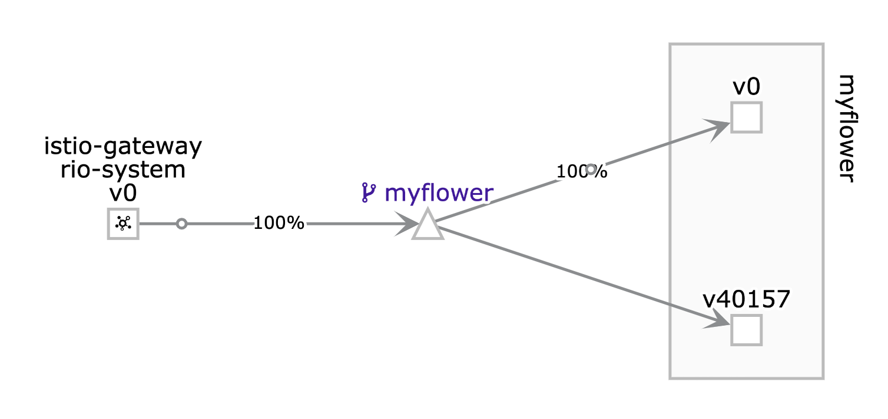

kiali1

This screen shot helps make clear the Rio concepts of **application** and **service**. An application contains multiple service revisions and a service is a scalable set of containers. In kubernetes terms you can think of a service as a deployment but an application does not really have a kubernetes equvilent. It is a meta object used to enable additional Rio functionality.

Now we are ready to promote our new revision and make it live. The rio promote command is used for this and it will gradually shift traffic over to the new revision. By default it will apply a 5% shift every 5 seconds.

# Promote service  
$ rio promote demo/myflower:v40157   
$ hey -z 3m -c 30 http://myflower-demo.xvw8xv.on-rio.io  
  
# timestamp 1 - Trffic is swiching over to v40157 it is receiving 15%  
Name CREATED ENDPOINT REVISIONS SCALE WEIGHT DETAIL  
demo/myflower 2 hours ago https://myflower-demo.xvw8xv.on-rio.io v0,v40157 1,1 85%,15%  
  
# timestamp 2 - Trffic is swiching over to v40157 it is receiving 35%  
Name CREATED ENDPOINT REVISIONS SCALE WEIGHT DETAIL  
demo/myflower 2 hours ago https://myflower-demo.xvw8xv.on-rio.io v0,v40157 1,1 65%,35%  
  
# timestamp 3 - Trffic is swiching over to v40157 it is receiving 55%  
Name CREATED ENDPOINT REVISIONS SCALE WEIGHT DETAIL  
demo/myflower 2 hours ago https://myflower-demo.xvw8xv.on-rio.io v0,v40157 1,1 45%,55%  
  
# timestamp 4 - Trffic is swiching over to v40157 it is receiving 75%  
Name CREATED ENDPOINT REVISIONS SCALE WEIGHT DETAIL  
demo/myflower 2 hours ago https://myflower-demo.xvw8xv.on-rio.io v0,v40157 1,1 25%,75%  
  
# timestamp 5 - Trffic is swiching over to v40157 it is receiving 95%  
Name CREATED ENDPOINT REVISIONS SCALE WEIGHT DETAIL  
demo/myflower 2 hours ago https://myflower-demo.xvw8xv.on-rio.io: v0,v40157 1,1 5%,95%  
  
# timestamp 6 - promotion complete 100% of the traffic is directed at v40157   
Name CREATED ENDPOINT REVISIONS SCALE WEIGHT DETAIL  
demo/myflower 2 hours ago https://myflower-demo.xvw8xv.on-rio.io v40157 1 100%

Here is what the promotion looks like in the Kiali UI. Just like above at each point we see the traffic switching over to v40157 revision until it reaches 100%

timestamp 1 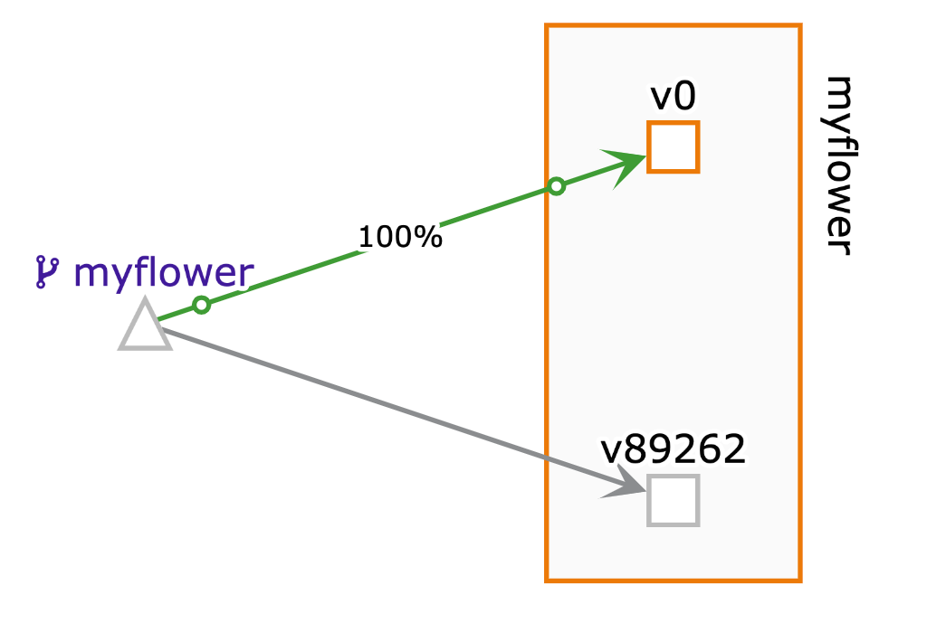

timestamp 2 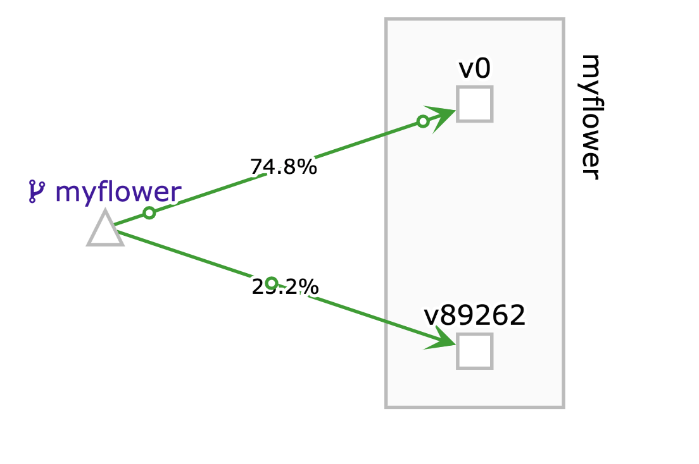

timestamp 3 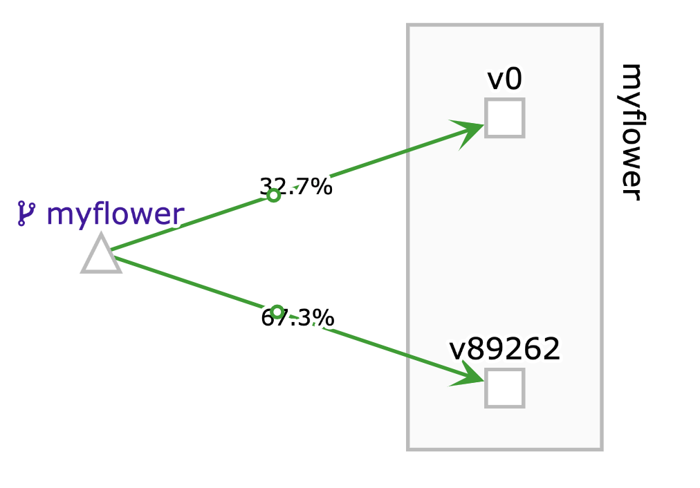

timestamp 4 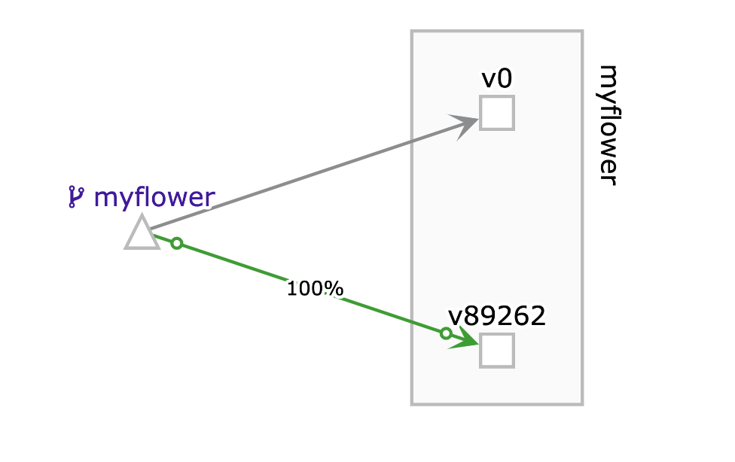

Grafana has several out-of-the-box dashboards for Istio. Here is a sample Istio Performance Dashboard for our service mesh:

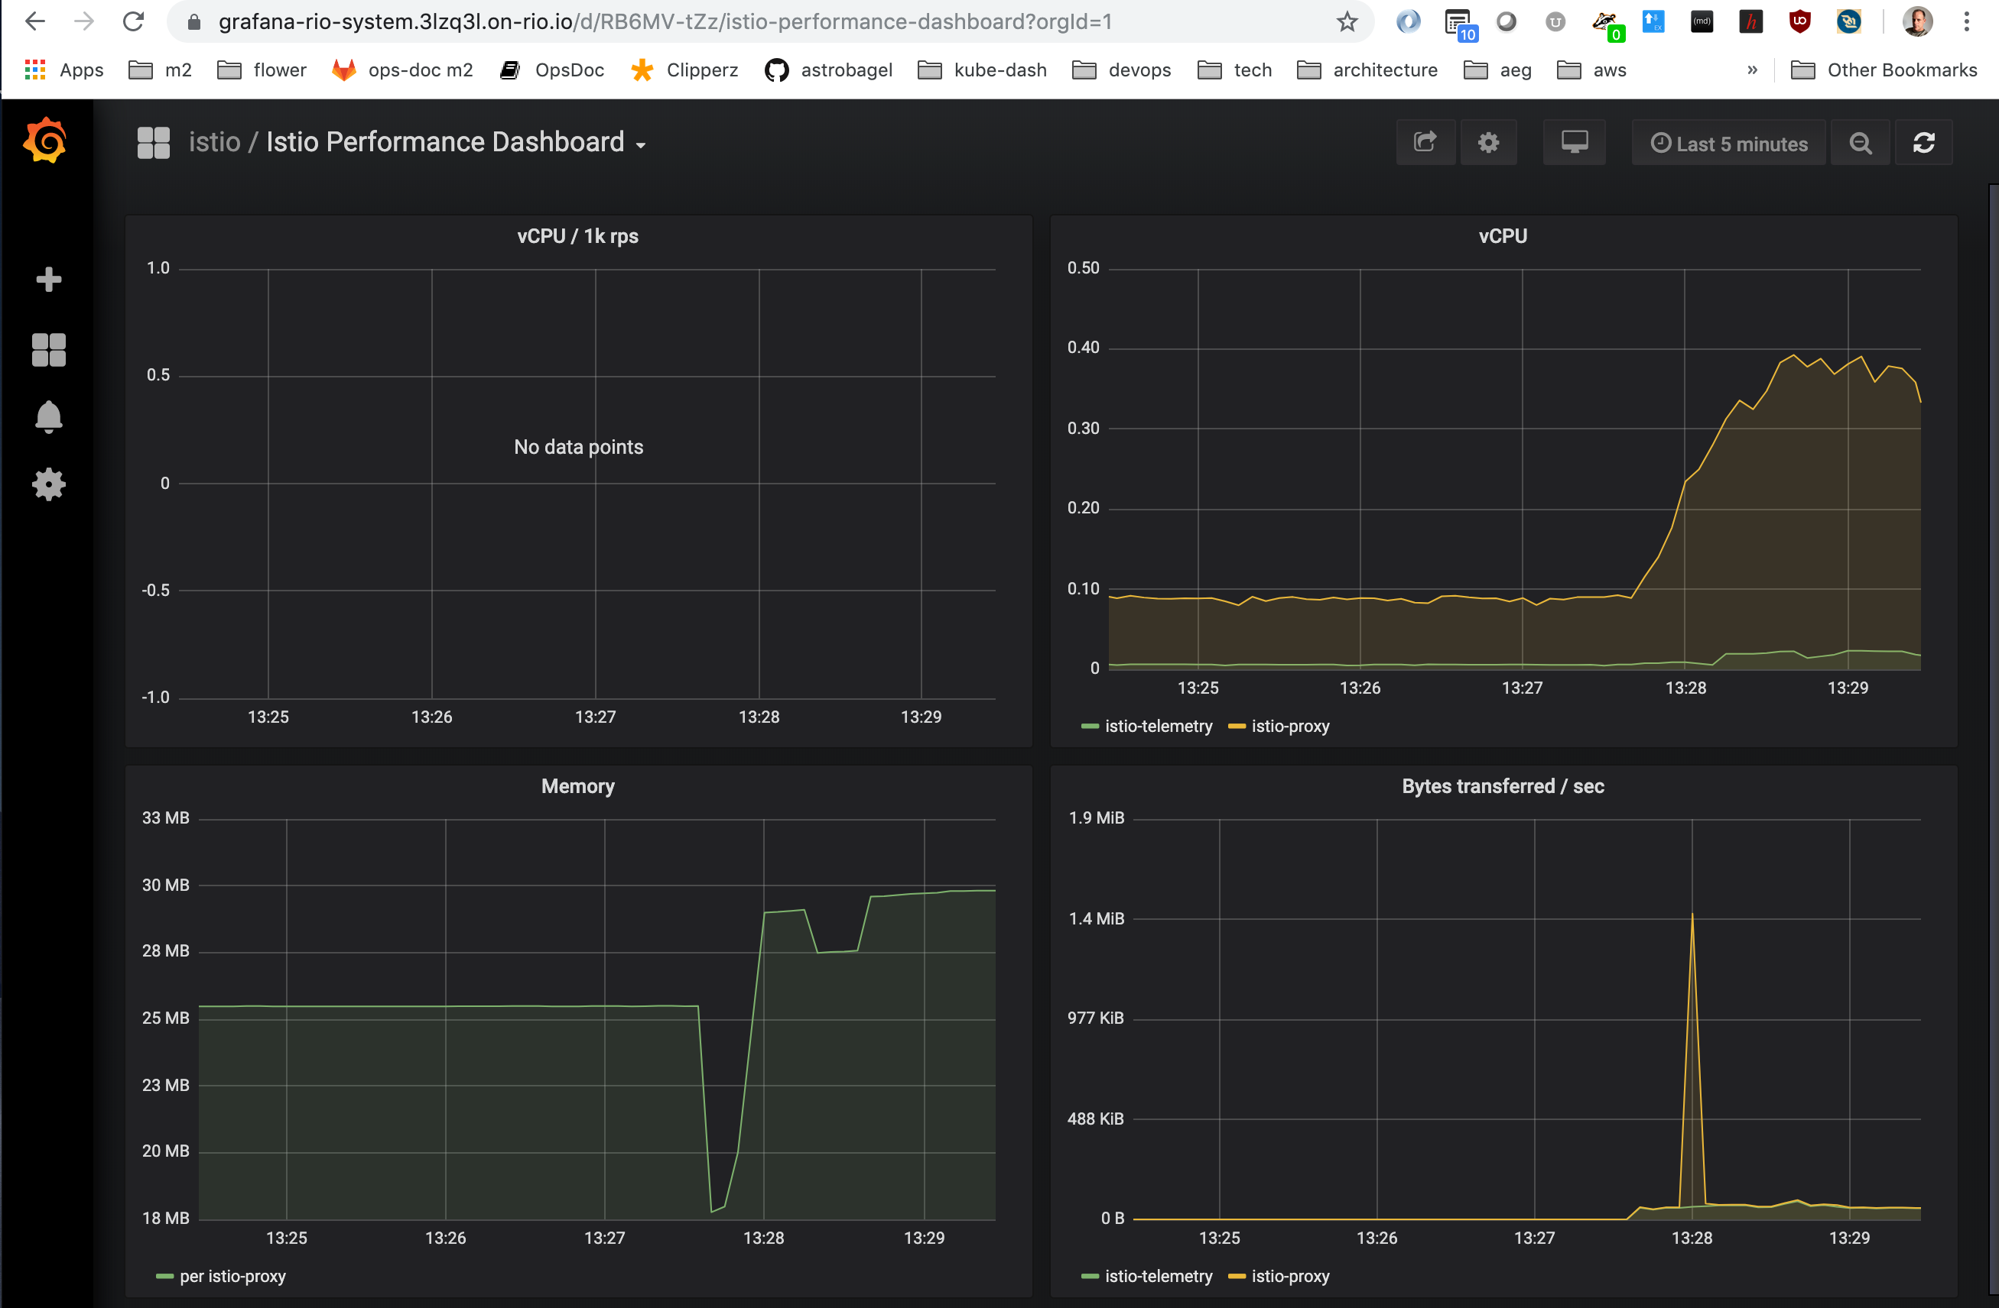

grafana performance dash

In some cases we don’t want to promote right away but instead we can choose to set the weights manually. Perhaps we want to give our new version 5% of the traffic and then watch it for a few days before so we can gain confidence that all is good before we promote.

Below are a few examples of how to set the weights manually:

# Manually adjusting weight between revisions  
$ rio weight demo/myflower:v0=80% demo/myflower:v40157 =20%

## What just happened

* We created a new service using rio run
* Rio generated a domain name for the service xvw8xv.on-rio.io
* Rio secured the service for us using Let’s Encrypt
* When we added load, Rio scaled the service up for us
* When we removed load, Rio scaled the service down for us
* When we installed a new revision, Rio automatically moved traffic to the newest app revision for us

That is alot of functionality and all we had to do was crate our docker images and issue a few Rio commands!

## Serverless

In this context serverless referrs to a form of autoscaling. It is the ability for a service to scale down to zero instances when there is no workload and then automaticlly scale up when a new request is made.

With a Rio service there are no language or execution time restrictions like the restrictions that can be found with some other serverless platforms. You are free to put anything you like in your container and the system will run it for as long as necessary. All you have to do is set the minimum and maximum autoscalling parameters and Rio will monitor the workload and scale it as neccessary. Consider a use case that would be dificult to accomplish on some serverless platforms. For example, some machine learning jobs want to allocate GPUs and take a long time to complete while at the same time are used infrequently. With the ability to scale the ML services to zero instances the GPU resources can be freed up for other jobs to use.

Let’s see autoscaling-to-zero in action.

Note that below we are creating a new service with scale 0 to 10 instances. Instead of creating a new service we should be able to modify our existing service but there is currently a bug in rio v0.4.0 that is preventing us from doing something like rio scale demo/myflower=0-10. The Rio team is aware and I expect that by the time you read this it will be fixed.

# create new service with ability to scale from 0 to 10 instances  
$ rio run --ports 80/http --scale=0-10 --name demo/myserverlessflower flower:yellow  
  
# wait a couple of minutes for the workload to scale to zero  
...  
  
# list the active instances aka containers, and we see there are none  
$ rio ps --containers  
NAME IMAGE CREATED NODE IP STATE DETAIL  
  
  
# list the services and notice we have a service endpoint eventhough there are no running service instances (SCALE 0/1  
$ rio ps  
NAME CREATED ENDPOINT REVISIONS SCALE WEIGHT DETAIL  
demo/myserverlessflower 2 minutes ago https://myserverlessflower-demo.7u0o75.on-rio.io v0 0/1 100%   
  
# make a service request and after a small "cold start" delay we see a response  
$ curl https://myserverlessflower-demo.7u0o75.on-rio.io  
{"Color":"yellow"}  
  
# Now when we list the service we see the SCALE is 1  
$ rio ps  
NAME CREATED ENDPOINT REVISIONS SCALE WEIGHT DETAIL  
demo/myserverlessflower 6 minutes ago https://myserverlessflower-demo.7u0o75.on-rio.io v0 1 100%   
  
# And we now see one instance of the service is active  
$ rio ps --containers  
NAME IMAGE CREATED NODE IP STATE DETAIL  
demo/myserverlessflower-86d94bfd64-42bf4/myserverlessflower flower:yellow 33 seconds ago docker-desktop 10.1.4.83 Running

In summary, serverless is just an autoscaling feature of Rio with the ability to scale to zero instances.

## Adding Router

Router is a set of L7 load-balancing rules that can route between your services. It can add Header-based, path-based routing, cookies and other rules.

# create route  
$ rio route add myflowerrt.demo to demo/myflower  
  
# display route URL  
$ rio route  
NAME URL OPTS ACTION TARGET  
demo/myflowerrt https://myflowerrt-demo.3lzq3l.on-rio.io to myflower,port=80  
  
# test route  
$ curl https://myflowerrt-demo.3lzq3l.on-rio.io   
{"Color":"yellow"}

Example uses cases include:

* Create router in a different namespace
* Create a route based path match
* Create a route to a different port
* Create router based on header
* Create router based on cookies
* Create route based on HTTP method
* Add, set or remove headers
* Mirror traffic
* Rewrite host header and path
* Redirect to another service
* Add fault injection
* Add retry logic
* Create router to different revision and different weight

In a future post we will take a closer look at Rio routing, for now you can see the [official Rio docs](https://github.com/rancher/rio/blob/master/docs/README.md#adding-router) for more information.

## Monitoring

We had a quick look at the Istio Performance Dashboard above but there is much more on monitoring and alerting that we will cover in a future post. For now I will leave it to you to look around.

To access Grafana:

rio -s ps  
  
#look for:  
https://grafana-rio-system.3lzq3l.on-rio.io

## Rio File

The rio run command is powerful but just like the docker run command it can quickly get out of hand and hard to maintain all the command line parameters. Therefore, Rio has added support for a more user-friendly docker-compose-style config file call Riofile. Riofile allows you define rio services, apps, routes, external services, configmap, and secrets.

For more information see the [official Riod docs](https://github.com/rancher/rio/blob/master/docs/README.md#using-riofile) for more information.